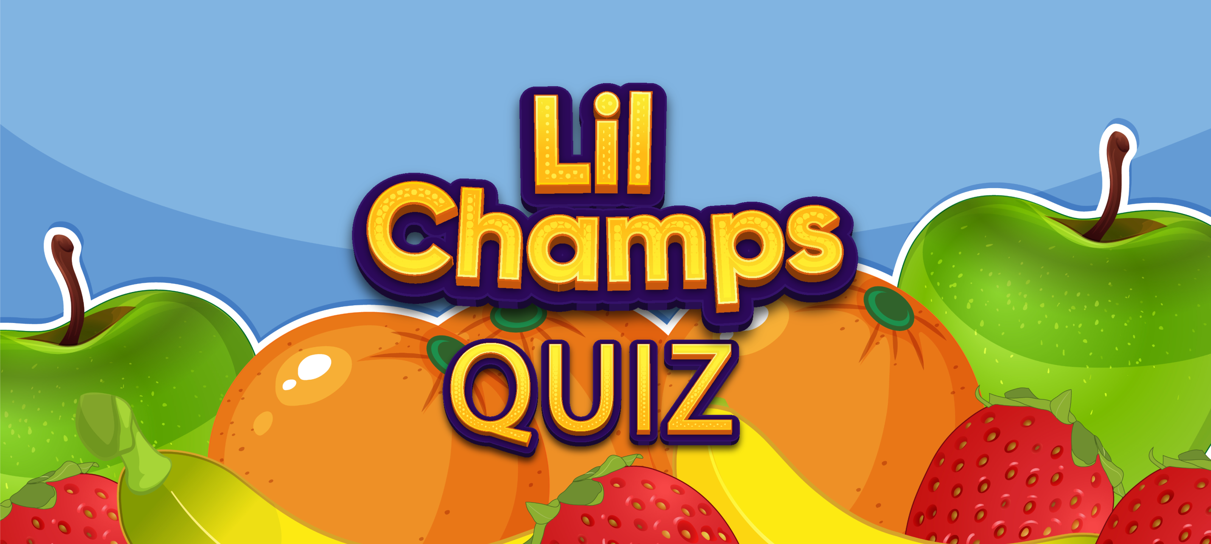

**Mission Statement:**

To develop an entertaining game for preschoolers to encourage learning.

---

**Stakeholders:**

|  |  |  |
| --- | --- | --- |
| **Users**  Preschoolers – 2 to 5 yrs old | **Parents** | **Teachers** |

**Name of the product:** Lil Champs Quiz

**Device:** 2D Mobile - Android

**Purpose:** To create an educational trivia quiz application for children aged between 2 and 5.

**MVP Key features:**

* **Age-Appropriate design:**

Since the game is targeted at young children, the user interface is simple and intuitive with colorful graphics and audio instructions.

* **Engaging Lesson:**

The game includes an engaging lesson that teaches children how to identify fruits with visual cues, audio cues and fun animations for effective learning.

* **Randomized options:**

The quiz includes randomized questions to ensure that the children are actually learning and not memorizing the answers. This will help them retain the information and develop critical thinking skills.

* **Feedback and rewards:**

The game provides positive feedback after each question whether the answer is right or wrong. The game is designed in such a way that the next question doesn’t load up until the previous question has been answered correctly. Rewards are given as stars at the end to encourage and appreciate the children for completing the quiz successfully.

**Benefits:**

* **Educational benefits:** The app helps children to develop knowledge on fruits, and how to identify them and improve their vocabulary.
* **Cognitive benefits:** Attending trivia quizzes will improve the children’s cognitive abilities such as attention, memory, and critical thinking.
* **Interactive learning:** The children can learn in a fun and engaging way and use their screen-time in a productive way.

**Future development and updates:**

We plan to expand the quiz beyond fruits to encompass various categories such as vegetables, animals, colors, and shapes. Additionally, we are exploring the possibility of implementing multiple levels of increasing difficulty to enhance the user’s overall experience.

Additional features:

1. Multiple language support

2. Trace the objects

3. Categories: Alphabets, numbers etc.

**Concept sketches:**

1. Splash scene:
   1. Logo
   2. Splash Animation



1. Menu scene:
   1. Start lesson button
   2. Start Quiz

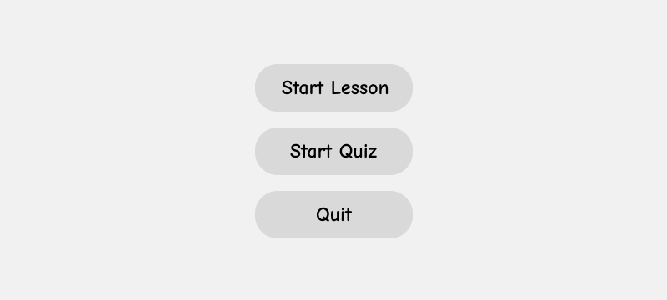

1. Lessen scene:
   1. Video panel
   2. Play button
   3. Replay button
   4. Back button (takes you to menu)

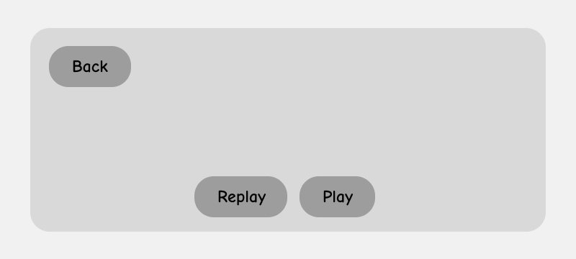

1. Quiz scene:
   1. Fruit images
   2. Audio and Text instruction
   3. Back button

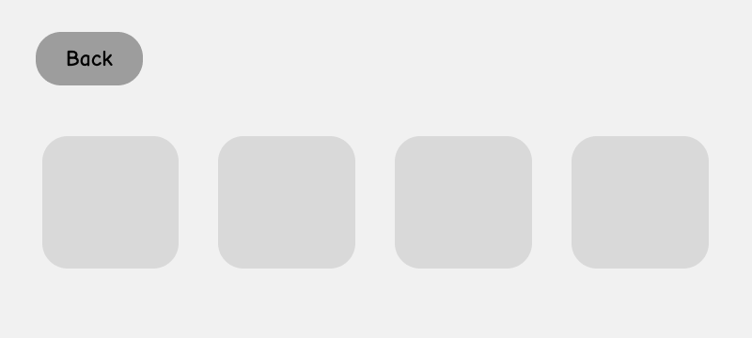

1. Congratulations scene:
   1. Success message
   2. Back button

